ELCT 302
Laboratory Report #1
Open-Loop Control & Obtaining Feedback
Group #2
4 October 2023

I hereby certify that I have complied
with the Spirit and the Letter
of the Carolinian Creed
in preparing this report

_________________Riley Hudson_______________
Riley Hudson

_________________Nicholas George_______________
Nicholas George

Department of Electrical Engineering
University of South Carolina
Columbia, SC 29208

Abstract
This experiment investigates the implementation of open-loop DC motor control and utilizes feedback to help understand the relationship between the speed and voltage of the DC motor. This is the first step in designing a system that autonomously operates a vehicle around a track. The vehicle must be able to travel according to a reference trajectory and by using open-loop controls, a desired speed can be obtained when given a specific voltage. Two permanent magnetic DC motors are used to observe the action created by an input. An encoder is used to obtain feedback for the motor speed. Control of the system and feedback are necessary in order for the vehicle to operate accurately and efficiently. The vehicle must have accurate information to make the required adjustments for proper performance.

Table of Contents
Abstract 1
Table of Contents 2
Table of Figures 3
Introduction 5
Main Specifications 5
Background 5
FRDM-KL25 Microcontroller and Analog-Digital-Converter (ADC) 6
Pulse Width Modulated Signals 7
Switching/Buck Converters 7
MOSFETs (IRF540) 8
Diodes (MBR1060) 9
Experimental Procedure 9
Discussion / Results 13
Conclusions 14
Appendix 15
Reference Voltage at 0.66 V 16
Reference Voltage at 1.32V 17
Reference voltage at 1.99V 17
Reference Voltage at 2.64V 18
Reference voltage at 3.24V 18
Code 19
References 21

Table of Figures
Figure 1 – System Diagram........................................................................................................... 4
Figure 2 - Illustration of how an ADC circuit operates................................................................. 5
Figure 3 - Illustration of duty cycle............................................................................................... 6
Figure 4 - Buck converter example............................................................................................... 7
Figure 5 - MOSFET example........................................................................................................ 7
Figure 6 - Tachometer example..................................................................................................... 8
Figure 7 - Voltage regulator circuit............................................................................................... 8
Figure 8 - Potentiometer with microcontroller.............................................................................. 9
Figure 9 - Pulse width modulation circuit..................................................................................... 9
Figure 10 - Implementation of the MOSFET.............................................................................. 10
Figure 11 - Implementation of the Schottky Diode..................................................................... 10
Figure 12 - Frequency to voltage converter................................................................................. 11
Figure 13 - Average Motor Voltage vs. Motor Speed................................................................. 12
Figure A1 – Full circuit diagram................................................................................................. 14
Figure A2 – Reference voltage at 0.66V..................................................................................... 15
Figure A3 – Duty Cycle at 0.66V................................................................................................ 15
Figure A4 - Encoder Frequency at 0.66V.................................................................................... 15
Figure A5 – Output voltage at 0.66V........................................................................................... 15
Figure A6 - Reference voltage at 1.32V...................................................................................... 15
Figure A7 - Duty Cycle at 1.32V................................................................................................. 15
Figure A8 - Encoder Frequency at 1.32V.................................................................................... 16
Figure A9 - Output voltage at 1.32V........................................................................................... 16
Figure A10 - Reference voltage at 1.99V.................................................................................... 16
Figure A11 - Duty Cycle at 1.99V............................................................................................... 16
Figure A12 - Encoder Frequency at 1.99V.................................................................................. 16
Figure A13 - Output voltage at 1.99V......................................................................................... 16
Figure A14 - Reference voltage at 2.64V.................................................................................... 17
Figure A15 - Duty Cycle at 2.64V............................................................................................... 17
Figure A16 - Encoder Frequency at 2.64V.................................................................................. 17
Figure A17 - Output voltage at 2.64V......................................................................................... 17
Figure A18 - Reference voltage at 3.24V.................................................................................... 17
Figure A19 - Duty Cycle at 3.24V............................................................................................... 17
Figure A20 - Encoder Frequency at 3.24V.................................................................................. 17
Figure A21 - Output voltage at 3.24V......................................................................................... 17

Open-Loop Control & Obtaining Feedback

Introduction
Laboratory 1 is the first step to reaching our goal of building a completely autonomous vehicle. In this lab, one must demonstrate understanding and implementation of open-loop DC motor control by designing a circuit to create a feedback signal for motor speed. One must also determine and demonstrate the speed-to-voltage relationship of the DC motor. Lab 1 was broken up into two weeks/sections with week 1 focusing on open-loop control and week 2 focusing on speed measurements. For the student’s benefit, the main specifications of the vehicle/motors are provided and are also shown below.

Main Specifications
- Motor Voltage: 7.2V
- Switching frequency: $≥20 kHz$
- Speed range: 0-100%
- Reference voltage range: 0 - 3.3 V
- Feedback: Incremental Encoder

Background
The focus of this lab is understanding and implementing open loop control. Though closed loop control will be used in later labs, open loop control is a good starting point because it ensures the system responds when an input is applied and/or changed. The disadvantages include not being able to correct errors at the output or anywhere throughout the system. An open-loop dc-dc buck converter similar to the schematics shown below.
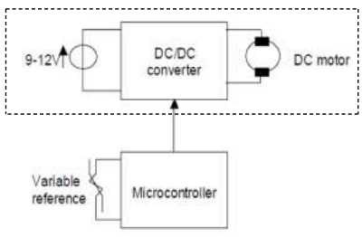
Figure 1. System Diagram

FRDM-KL25 Microcontroller and Analog-Digital-Converter (ADC)
The FRDM-KL25 microcontroller is a versatile and powerful embedded system designed to meet the demands of a wide range of applications. It is built around the ARM Cortex-M0+ core, offering a balance of performance and energy efficiency, making it an ideal choice for this lab. The electrical characteristics are studied beforehand to ensure that it was not damaged when implemented in the circuit.
A basic ADC circuit is comprised of comparators. A voltage input $V_{in}$ signal is applied to the input of the comparator, while a reference voltage $V_{REF}$ is applied to the other. A comparison of the voltages is made, and the output of the comparator will either be high or low.
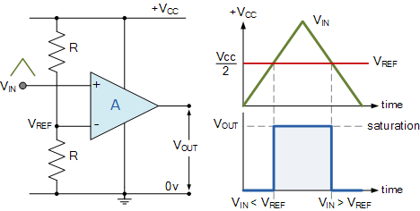
Fig. 2. Illustration of how an ADC circuit operates
One comparator could be considered a 1-bit ADC. To increase the bit size of the ADC, comparators are stacked. The general equation is:
$n-bit ADC=2^{n}-1$ (Eq. 1)
The FRDM-KL25 utilizes a 16-bit ADC (65,536 distinguishable outputs) and uses an AnalogIn API to read an external voltage applied to an analog input pin. The resolution of the ADC can be calculated to find the amount of voltage required to make a change in the digital output.
$\frac{V_{max}}{distinguishable outputs}$ (Eq. 2)
The voltage is read as a fraction of the system voltage. This value is a floating point from 0.0 $V_{SS}$ to 1.0 $V_{CC}$. A change in analog voltage, given by the equation above, will create a change in the digital output voltage by:
$\frac{1}{distinguishable outputs}$ (Eq. 3)

Pulse Width Modulated Signals
PWM signals are a fundamental and widely used technique in electronics and control systems. They will be used in this lab to efficiently control the average power delivered to the motor by varying the width/duration of high and low voltage pulses within a fixed period. The time it takes for each pulse is defined as the period (T) of the waveform and is inversely proportional to the frequency f.
$T=\frac{1}{f}$ (Eq. 4)
The duty cycle is the relationship between the time on and time off.
$D=\frac{T_{on}}{T_{on}+T_{off}}=\frac{T_{on}}{T}$ (Eq. 5)
With the output waveform of the PWM being a square wave, the voltage output of the PWM will be equal to the average voltage.
$V_{out}=V_{in}×D$ (Eq. 6)
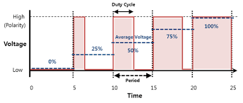
Fig. 3. Illustration of duty cycle
It should be noted that the KL25Z microcontroller’s 16-bit ADC can operate at frequencies of 2 to 12 MHz or up to 83.33 ns. While the GPIO can operate at up to 62.5 MHz or 16 ns.

Switching/Buck Converters
A switching converter is a vital component in modern power electronics, serving as a transformative technology for efficient voltage regulation and energy conversion. One of the most used switching converters, as well as the dc-dc converter used in this lab, is the buck converter. A buck converter is a voltage step-down device that efficiently reduces an input voltage to a lower output voltage level. It achieves this by rapidly switching a semiconductor switch (MOSFET) to control the flow of energy to an output load (motor).
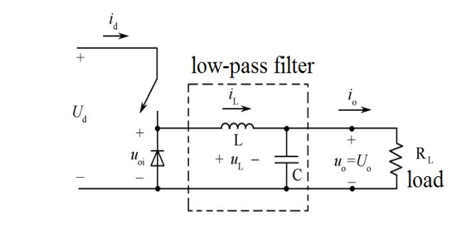
Fig. 4. Buck converter example

MOSFETs (IRF540)
Metal-Oxide-Semiconductor Field-Effect Transistors, commonly known as MOSFETs are essential semiconductor devices that play a pivotal role in modern electronics and power management systems. MOSFETs are known for their ability to efficiently control the flow of electrical current based on an applied voltage at its gate terminal.
In a buck converter, MOSFETs act as the primary switching element that controls the flow of electrical energy from the input source to the output load. They do so by rapidly switching on and off in response to a control signal. When the MOSFET is turned on, it allows current to current to flow from the input to the output. When off, it interrupts the flow of current. By adjusting the duty cycle (PWM), the buck converter can regulate the output voltage to the desired level.
An N-channel MOSFET was utilized as the switch for the converter. A MOSFET has a gate, source, drain, and body. Typically, the source and body are internally connected. When a voltage is applied to the gate-source $V_{GS}$, and it is higher than the threshold voltage $V_{TH}$, current will flow.
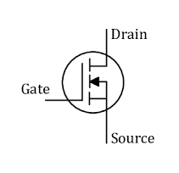
Fig. 5. MOSFET example

Diodes (MBR1060)
Diodes are fundamental semiconductor devices that serve a crucial role in modern electronics as well as buck converters. A diode is a two-terminal semiconductor device that only allows the flow of electrical current in one direction. Diodes are employed in buck converters as rectifiers to convert the alternating current produced during the switching of the MOSFET into a smooth and continuous direct current that is used to power the load.

Feedback
To operate both accurately and efficiently, the vehicle must have an idea of its current speed to make necessary adjustments to its performance. For the second part of this lab, an optical sensor is used in conjunction with a frequency to voltage converter to create a tachometer (shown in Figure 5). The feedback produced by the tachometer will be sent back to the microcontroller as seen in Figure 2.
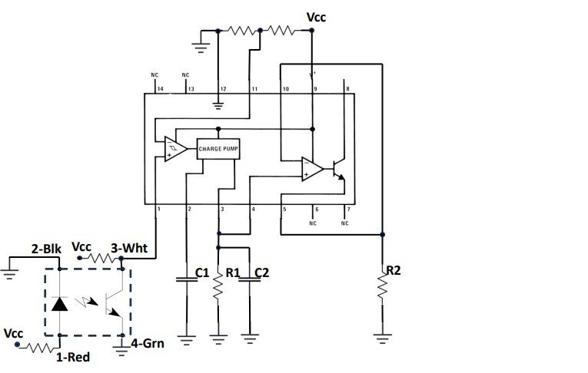
Fig. 6. Tachometer example

Experimental Procedure
The first step in building this circuit was determining a proper power source to run the vehicle components. To test the vehicle’s open-loop control and feedback, a DC voltage of 10V was utilized from a DC power supply. This supplies enough power for the 7.2V motors, however, some components like the microcontroller cannot take in this voltage. A voltage regulator is used to take the 10V supplied and output a constant 5V.
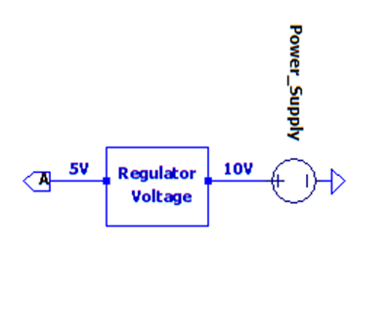
Fig. 7. Voltage regulator circuit
An input voltage reference is used to manipulate the output of the motor's speed. This is broken down into multiple processes. The microprocessor contains a pin that outputs 3.3V. A voltage divider circuit with a potentiometer creates an adjustable output from 0V to 3.3V. The output is then fed into an analog input of the microcontroller to obtain a voltage reference that can be controlled.
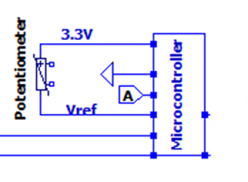
Fig. 8. Potentiometer with microcontroller
Using the analog-to-digital converter API driver of the microprocessor (seen in the code section of the report), the analog voltage is converted into a digital voltage. In this conversion, a small percent error is expected. The digital voltage of the 16-bit ADC will only change in increments of 15µV. For this change to occur, the analog voltage must change by 50µV, as can be seen from Equation 1 through Equation 3. Continuing to utilize the microcontroller, A PWM signal is generated based on the digital voltage. The frequency of the signal was set to 25kHz. The signal is sent to a gate driver, which boosts the current and inverts the waveform. This inversion was adjusted for in the initial PWM signal output.
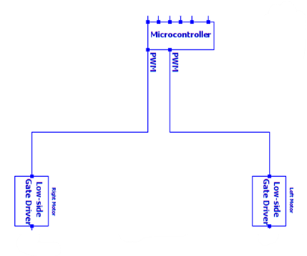
Fig. 9. Pulse width modulation circuit
Output of the gate driver is used as the input for the gate of the MOSFET. In this process of the open-loop control, more errors are expected. The voltage potential outside the gate driver is greater than wanted at the gate of the MOSFET. To reduce the gate voltage of the MOSFET two resistors are placed between the components. A 100kΩ resistor is tied to the ground in parallel with a 10Ω resistor that is tied to the gate of the MOSFET. These resistors are not ideal and have 5% tolerances. A small percent error will be created due to non-ideal resistors. There will also be small voltage losses in the gate driver and MOSFET components.
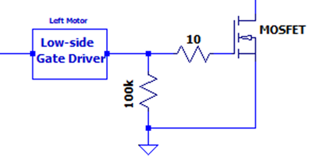
Fig. 10. Implementation of the MOSFET
The MOSFET acts as the switch of the buck converter to step down the voltage supplied from the 10V power supply, while increasing the current based on the input signal. Provided the signal is strong enough to overcome the threshold voltage of the MOSFET, the motor will run. When the input signal is increased the motor speed increases proportionally. There will be small voltage drops across the Schottky diode and motor.
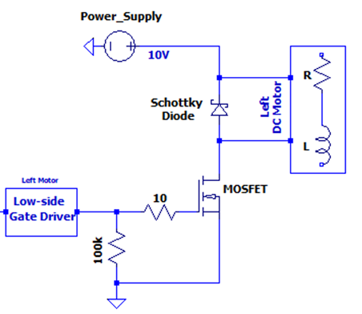
Fig. 11. Implementation of the Schottky Diode
Obtaining feedback was done by measuring the output speed of the motors and comparing that speed to the reference voltage. An encoder attached to the vehicle produced a signal proportional to the rotational frequency of the tires. The encoder was powered by 5Vdc from the voltage regulator. The resistors used to produce the current required by the encoder are not ideal. This will cause some distortion of the signal output. The signal produced by the encoder is sent to a frequency to voltage regulator. The values for the resistor and capacitors, to create a tachometer, were selected to produce a max voltage of 3.3V when the motors are running at max speed. The resistor and capacitor values were limited due to material availability. This will cause an error in the output voltages.
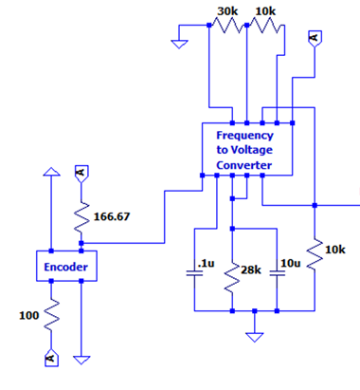
Fig. 12. Frequency to voltage converter
Output voltages of both motors are then sent back to the microcontroller to be compared to the original reference voltage. An Oscilloscope captured images of the signals produced by varying reference voltages. The reference voltage, PWM signal, encoder signal, and voltage output were captured to observe the open-loop control and feedback of the circuit. Screenshots can be seen in Figure A2 to Figure A21 in the appendix.

Discussion / Results
Ideally, the duty cycle of the PWM signal generated by the microcontroller would be exactly proportional to the reference voltage in comparison to the maximum voltage. It was found that the signal produced had an average percent error of 6%. This can be seen in the oscilloscope images found in the appendix, Figure A2 to Figure A21, as well as the table below.
Measurements | Input $V_{ref}$ | Ideal Duty Cycle | Duty Cycle Before Gate Driver | Duty Cycle After Gate Driver | Percent Error
1 | 0.642 | 0.194545455 | 0.7662 | 0.2338 | 16.78979703
2 | 1.32 | 0.4 | 0.5678 | 0.4322 | 7.450254512
3 | 2 | 0.606060606 | 0.3662 | 0.6338 | 4.376679385
4 | 2.64 | 0.8 | 0.166 | 0.834 | 4.076738609
5 | 3.28 | 0.993939394 | 0.032 | 0.968 | -2.67968946
Table 1. Measurements of the reference voltage applied to the microcontroller and the PWM signal created by that voltage.
The encoder utilized requires an input current to the diode of 50mA and an output collector current of 30mA. Calculating using Ohm’s Law and an input voltage of 5V, a 100Ω resistor and 167Ω resistor is required. The resistor for the diode current was available and used, but the resistor for the collector current was not available. A 180Ω resistor was used instead, giving a current of 27mA instead.
$$50mA=\frac{5V}{100Ω}$$
$$27mA=\frac{5V}{180Ω}$$
The frequency-to-voltage converter required additional components to operate as a tachometer. When the motors were at max speed the frequency was found to be 900Hz. The capacitor for the charge pump needed to be higher than 500pF to operate properly so a 1nF capacitor was chosen. The output current of the frequency-to-voltage converter needs to be internally fixed by a resistor. An ideal max voltage output of 3.3V is wanted. When the motor is operating at a max frequency of 900Hz and a $V_{cc}$ of 5V a 28kΩ is required.
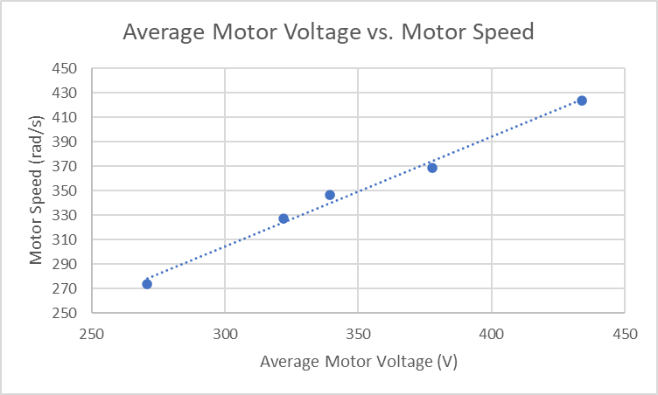
Fig 13. Average Motor Voltage vs. Motor Speed
Error observed from the tachometer affected the frequency and output voltage, but the relationship between voltage applied and the motor speed remained linearly proportionate.
$V_{ref}$(V) | $$V_{refadc}$$ | Duty Cycle | $f_{encoder}$Left (Hz) | $f_{encoder}$Rght  (Hz) | $V_{out}$  Left (RMS) | $V_{out}$ Right (RMS) | $$V_{outadc}$$ | Wheel Speed Left | Wheel Speed Right | Average Motor Speed | Average Motor Voltage
0.66 | 0.2 | 0.24 | 578 | 585 | 0.66 | 0.57 | 0.173 | 36.1 | 36.6 | 270.9 | 274.2
1.32 | 0.4 | 0.44 | 687 | 699 | 1.67 | 1.50 | 0.455 | 42.9 | 43.7 | 322.0 | 327.7
1.99 | 0.6 | 0.632 | 806 | 787 | 1.95 | 1.79 | 0.542 | 50.4 | 49.2 | 377.8 | 368.9
2.64 | 0.8 | 0.83 | 926 | 926 | 2.32 | 1.88 | 0.570 | 57.9 | 57.9 | 434.1 | 434.1
3.28 | 0.99 | 0.966 | 724 | 740 | 2.53 | 1.90 | 0.576 | 45.2 | 46.3 | 339.4 | 346.9
Table 2. Measurements at different reference voltages
Table 2 shows the measurements from this lab. The first three rows perform as expected, but rows five and six show some irregularities. Although the encoder frequency decreases, the output voltage increases. Multiple measurements were taken at both reference voltages and the values stayed constant. In future labs, this problem will be addressed and most likely resolved. To show that the circuit is working properly, the average motor voltage is plotted against motor speed to prove linearity. This is illustrated in the figure below.

Conclusions
The created circuit was successful in demonstrating open-loop DC motor control. The circuit was also successful in obtaining a feedback signal for the motor speed. It was found that the microcontroller's ability to produce waveforms that can change with a voltage reference was accurate. The 16-bit ADC and PWM output was precise. On average there was a 6% error in the production of the PWM output. Using this signal as the gate for the switching of the buck converter was essential to control speed. The frequency of the switching was high enough that the motor could operate without pause. The frequency of the PWM output was precisely 25kHz, creating zero error.
Ideal voltage outputs were not found, and this was expected due to the tolerance of components and voltage drops across components. At lower speeds, the accuracy between input and output was over 99%. What was not expected was the amount of noise from the circuit at higher speeds. The accuracy dropped to about 80% when at full speed. This may be from the motor, or it may be caused by light refraction. The encoder uses light sensors, so reducing the amount of outside light may give more accurate measurements. This is hard to implement in circuit design, as the vehicle should be able to operate in a multitude of environments with varying light. It is better to utilize closed-loop control and create an algorithm to account for these discrepancies.

Appendix
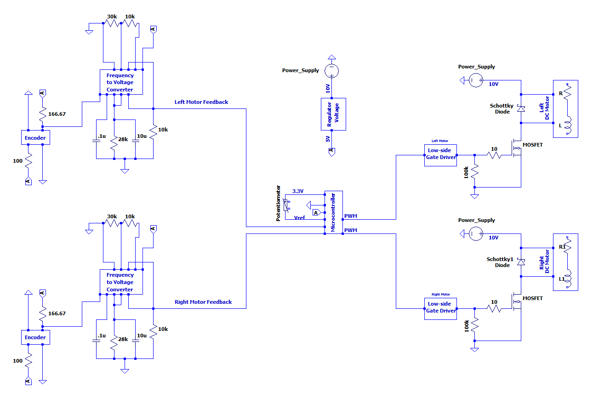
Fig. A1. Full circuit diagram

Reference Voltage at 0.66 V
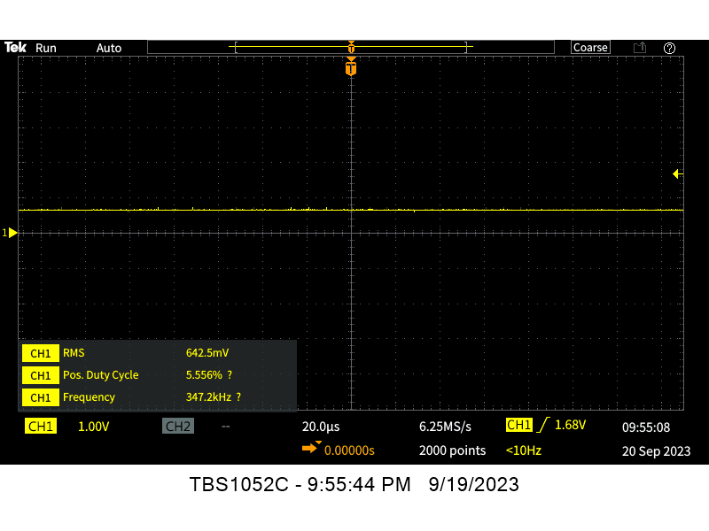Fig. A2. Reference voltage | 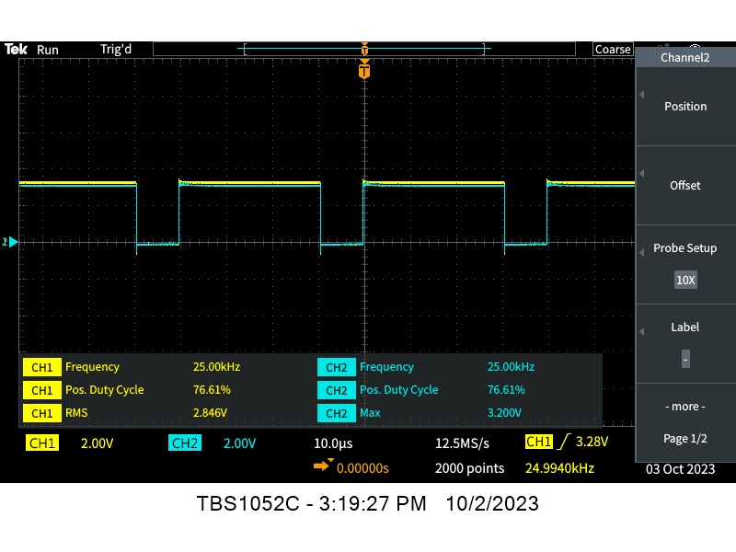Fig. A3. Duty cycle
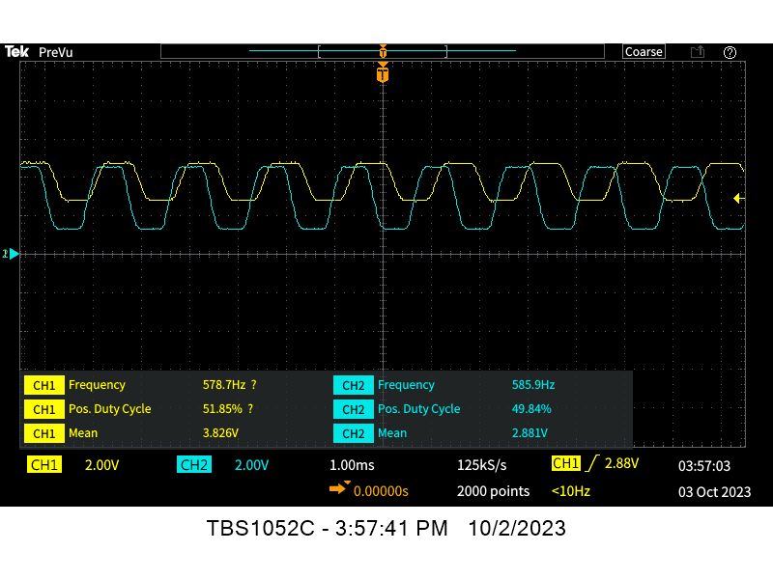Fig. A4. Encoder Frequency | 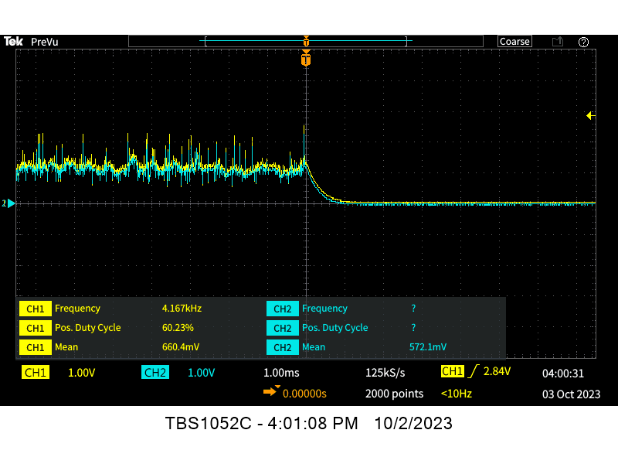Fig. A5. Output voltage

Reference Voltage at 1.32V
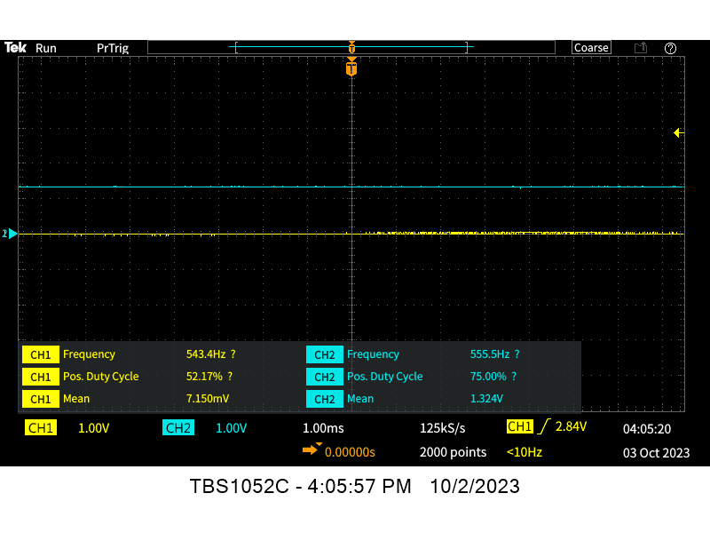Fig. A6. Reference voltage | Fig. A7. Duty cycle
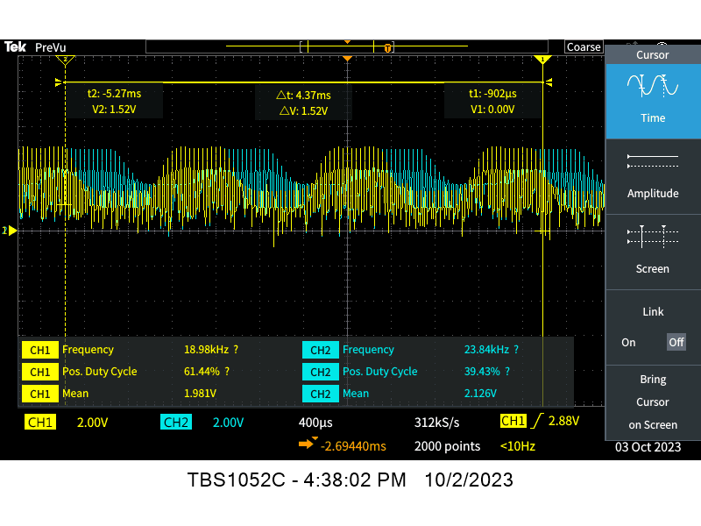Fig. A8. Encoder Frequency | 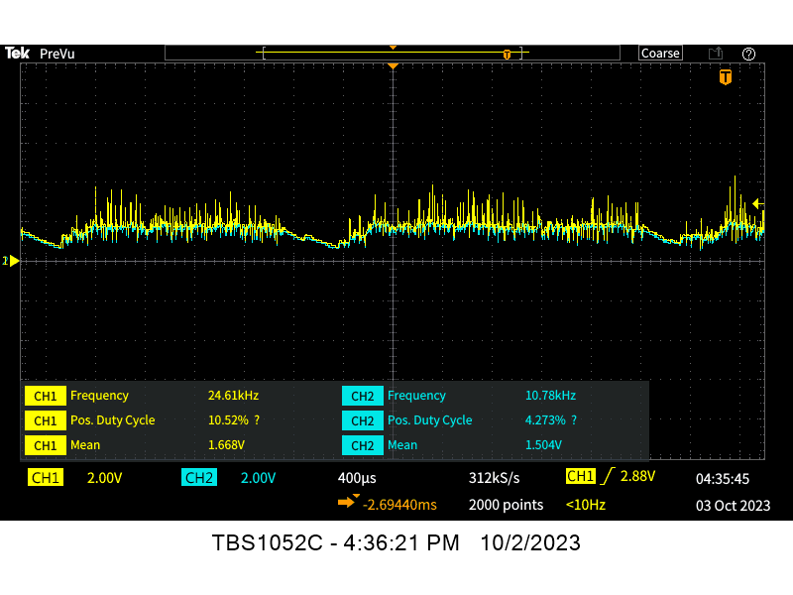Fig. A9. Output voltage

Reference voltage at 1.99V
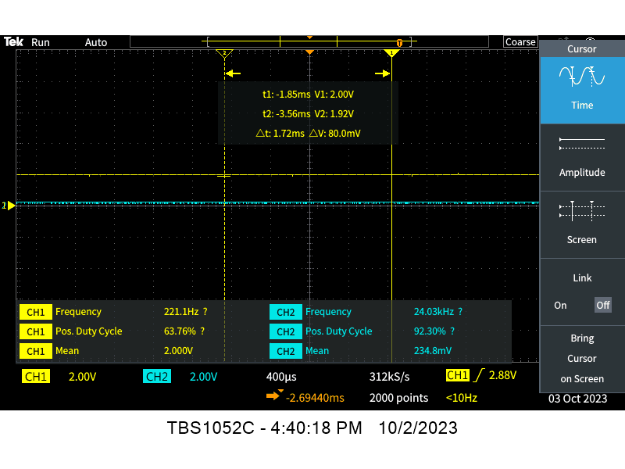Fig. A10. Reference voltage | 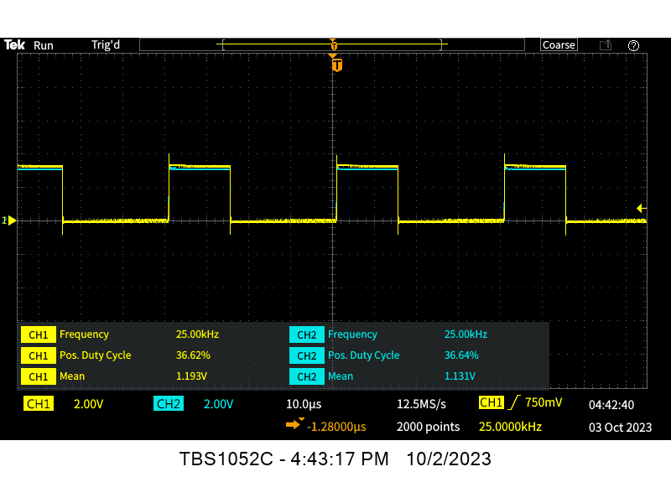Fig. A11. Duty Cycle
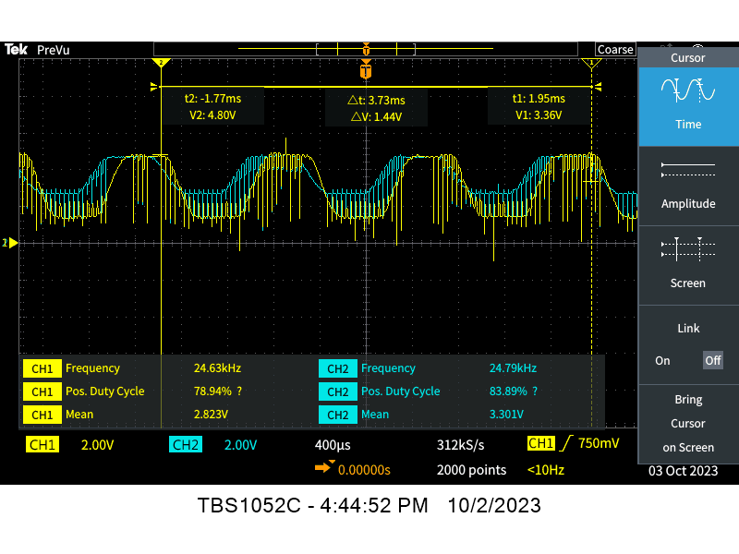Fig. A12. Encoder frequency | 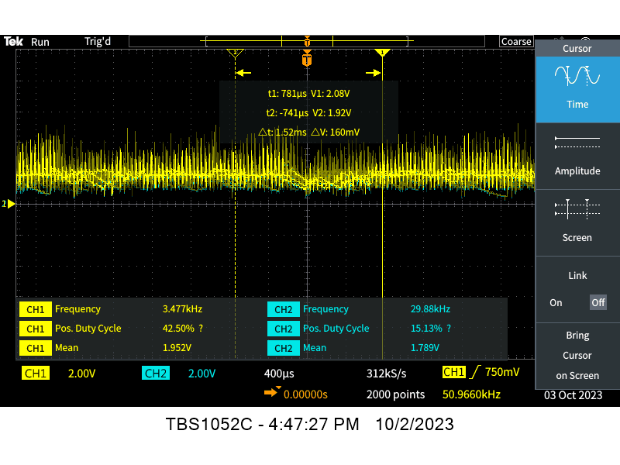Fig. A13. Output voltage

Reference Voltage at 2.64V
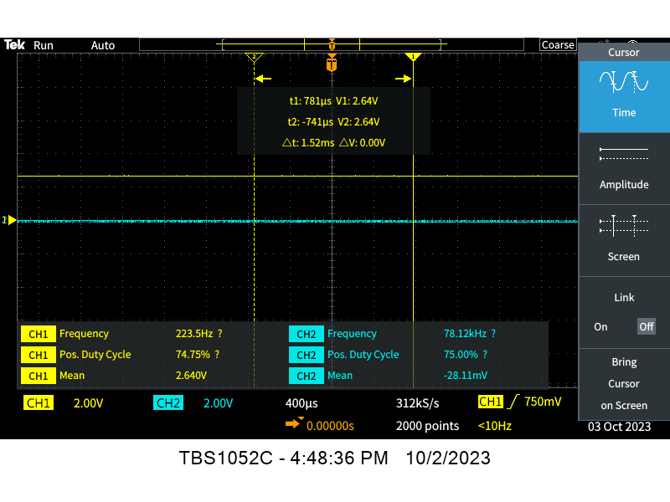Fig. A14. Reference voltage | 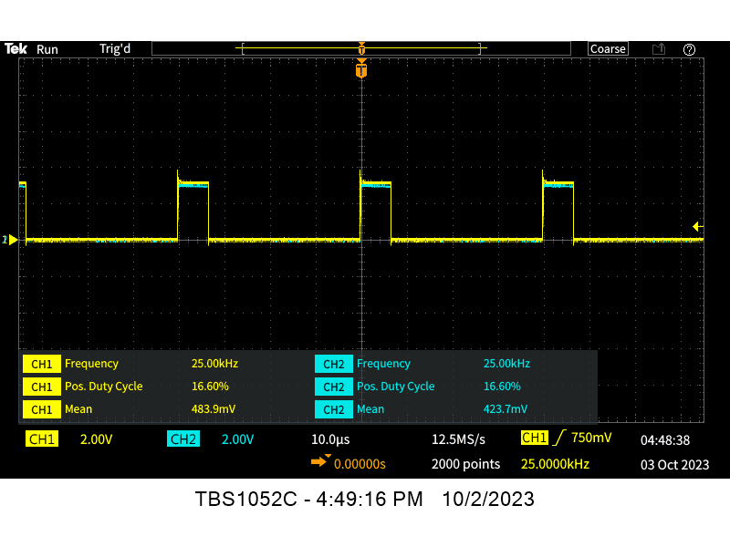Fig. A15. Duty cycle
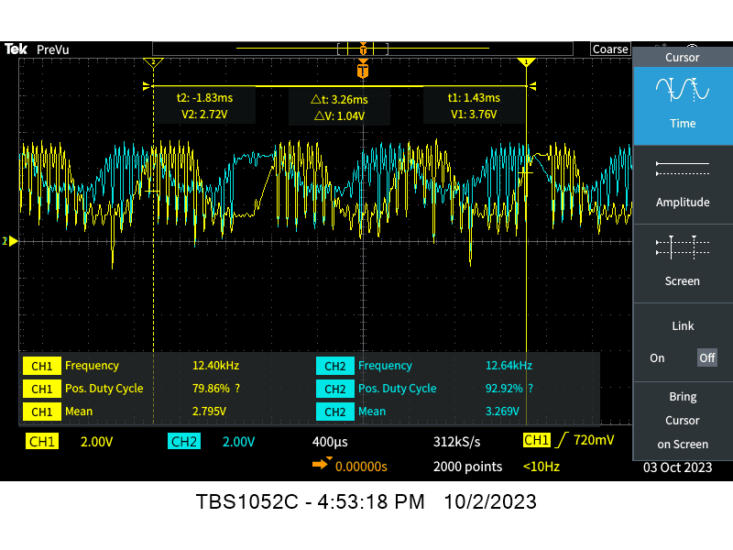Fig. A16. Encoder frequency | 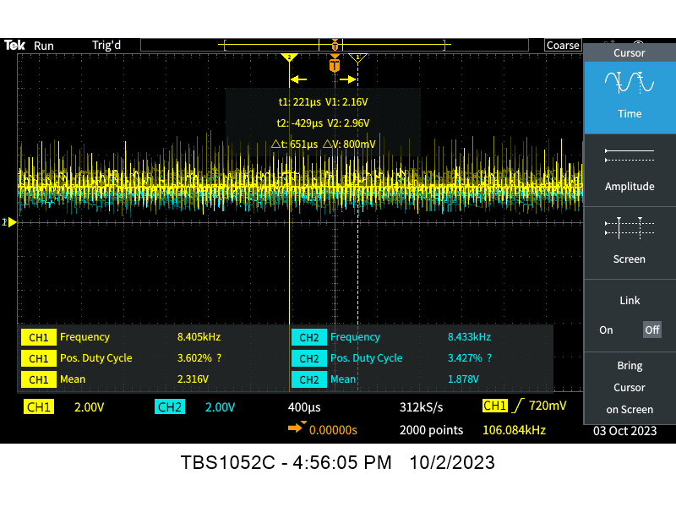Fig. A17. Output voltage

Reference voltage at 3.24V
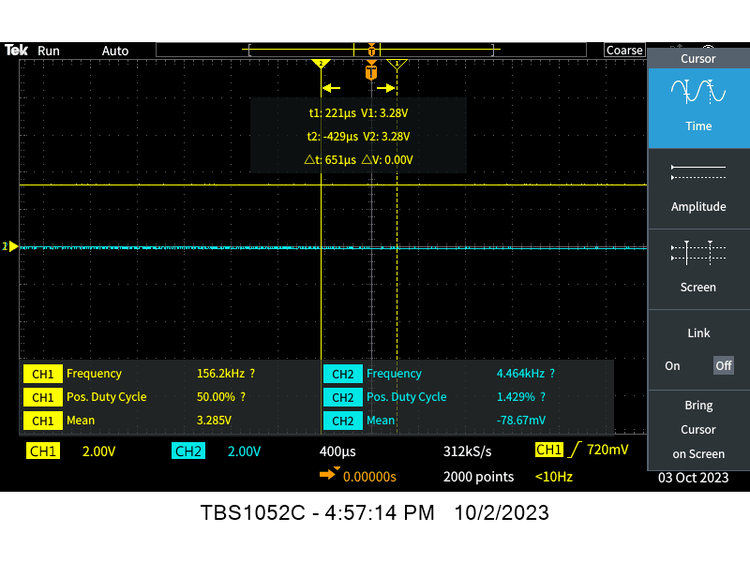Fig. A18. Reference voltage | 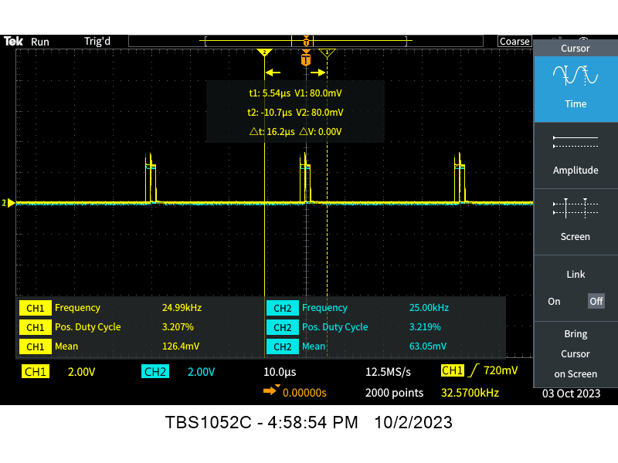Fig. A19. Duty cycle
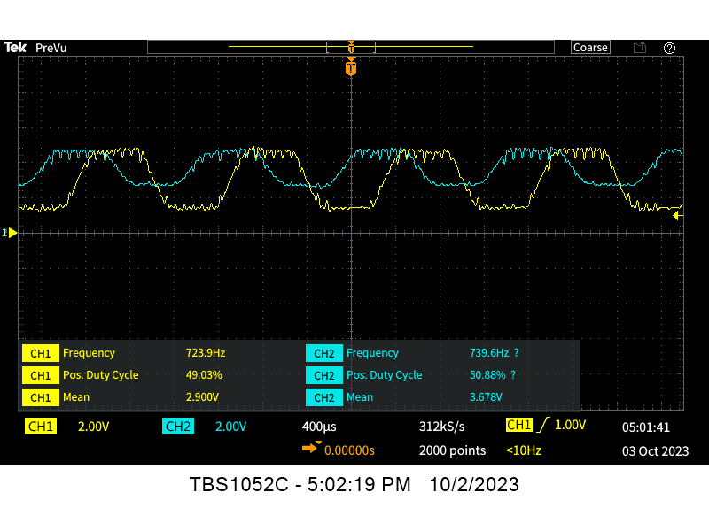Fig. A20. Encoder frequency | 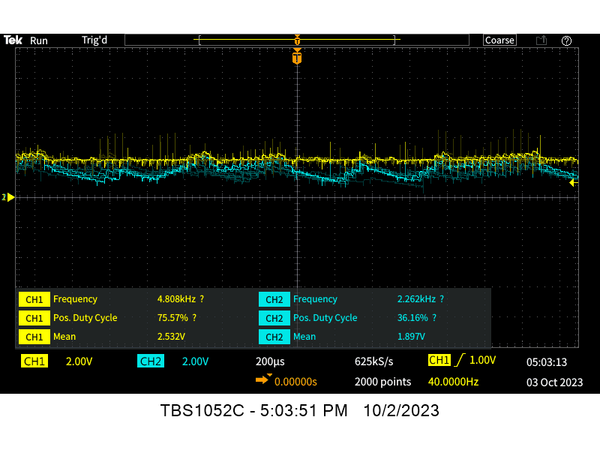Fig. A21. Output voltage

Code
#include "mbed.h"
//#include "unistd.h"
//#include "pinmap.h"

// Voltage into the microcontroller from the voltage divider
AnalogIn potV(A0);
// Voltage into the microcontroller from the right motor speed
AnalogIn rmV(A1);
// Voltage into the microcontroller from the right motor speed
AnalogIn lmV(A2);
// Pulse width to the right motor
PwmOut poutRM(D0);
// Pulse width to the right motor
PwmOut poutLM(D1);

// Instantiate variables
float vref = 0.0;
float vrm = 0.0;
float vlm = 0.0;
// Code for print function on tera term
static BufferedSerial serial_port(USBTX, USBRX, 9600);
FileHandle *mbed::mbed_override_console(int fd)
{
return &serial_port;
}
// Main code
int main() {

// Set period of pulse widths
//poutRM.period_us(40);
//poutLM.period_us(40);
poutLM.period(1.0f/25E3f);
poutRM.period(1.0f/25E3f);
// While motor running
while (1) {

// Read the incoming voltage from pot
vref = potV.read();

// Print digital voltage input
printf("Digital voltage input %1.4f\r", vref);

//Send pulse width according to inverted duty cycle. The waveform is flipped at the gate driver.
poutRM.write(1.0f-vref);
poutLM.write(1.0f-vref);

// Read incoming voltage from wheel speed
vrm = rmV.read();
vlm = lmV.read();

// Print wheel speed voltage values
printf("Voltage right motor %1.4f\r", vrm);

printf("Voltage left motor %1.4f\r", vlm);

//Wait
//usleep(40);
}
}

References
- TC4428 Datasheet
- MBR1060 Datasheet
- IRF540 Datasheet
- LM2907 Datasheet
- L7805CV Datasheet
- Slotted Optical Sensor Datasheet
- FRDM-KL25Z Datasheet
- Motor Datasheet

